1. Papers With Code:

<https://paperswithcode.com/paper/wav2vec-2-0-a-framework-for-self-supervised>

1. wav2vec 2.0: A Framework for Self-Supervised Learning of Speech Representation (2020)  
   <https://arxiv.org/pdf/2006.11477.pdf>

* Youtube Tutorial for Research Paper:[**https://www.youtube.com/watch?v=8Kpowre6yyk**](https://www.youtube.com/watch?v=8Kpowre6yyk)
* Krishna D N:  
  <https://www.youtube.com/watch?v=aUSXvoWfy3w>
* CMU Talk: <https://www.youtube.com/watch?v=u5Bldiey4zc>

1. WAV2VEC: UNSUPERVISED PRE-TRAINING FOR SPEECH RECOGNITION (2019)  
   <https://arxiv.org/pdf/1904.05862.pdf>
2. Github Resources:
   1. <https://github.com/pytorch/fairseq>
   2. <https://github.com/huggingface/transformers>
3. Github Repositories:
   1. <https://github.com/pytorch/fairseq/tree/master/examples/wav2vec>
   2. <https://github.com/mailong25/self-supervised-speech-recognition>
   3. <https://github.com/cristoper/wav2vec>
   4. <https://github.com/maxidl/wav2vec2>
4. Useful Youtube Tutorials:
   1. English Audio Speech-to-Text Transcript with Hugging Face   
      -<https://www.youtube.com/watch?v=dJAoK5zK36M>  
      -<https://colab.research.google.com/drive/1pTkj1HE768-3aM4huTWX5og8GkUKxKRi?usp=sharing>

# Facebook's Wav2Vec using Hugging Face's transformer for Speech Recognition <https://www.youtube.com/watch?v=Ivz-E2eBUZM>

* 1. Build Speech Recognition for any Language with 🤗 Transformers - Finetune XLSR-Wav2Vec2 (Hindi)  
     <https://www.youtube.com/watch?v=dAbtQRDaoro>

**Wav2vec2.0 architecture**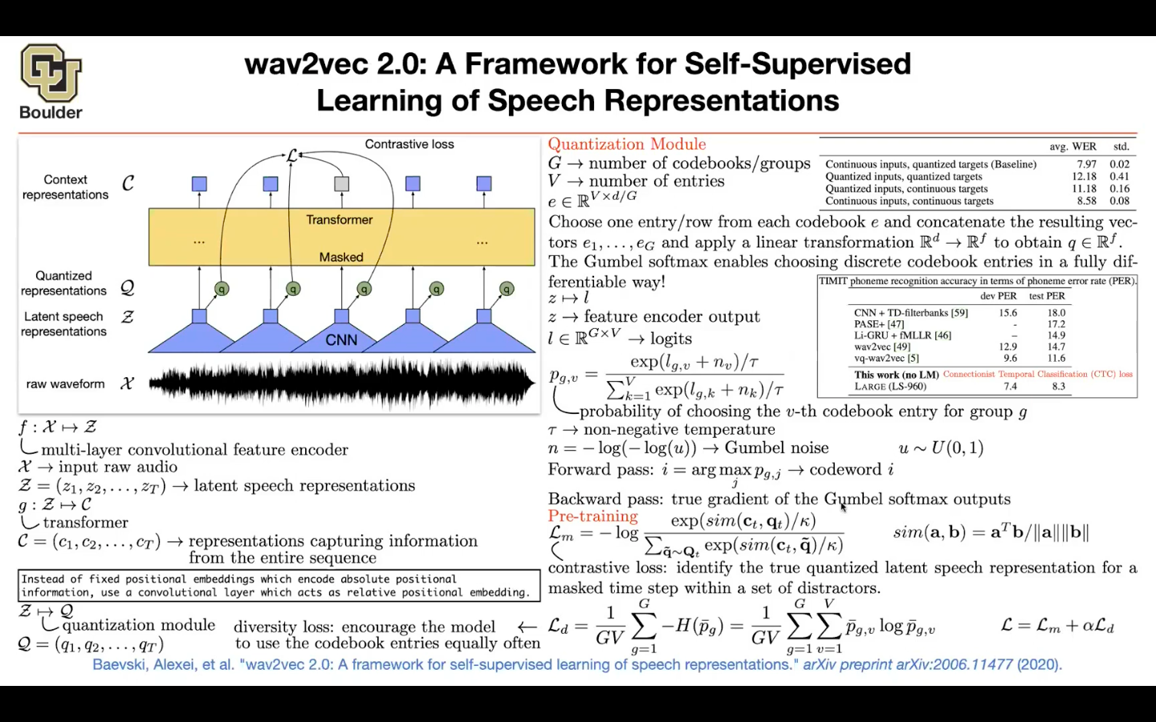

**Fine-Tuning Hugging Face Model with Custom Dataset:**<https://www.youtube.com/watch?v=HzwM0ClAmOM>  
<https://huggingface.co/blog/fine-tune-wav2vec2-english>